<university logos redacted>
Visual life-logging study
Participant information and consent form
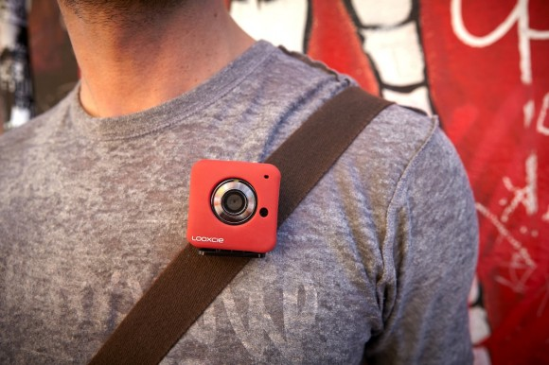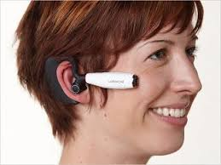

Purpose of Study
Life-logging is the practice of capturing and documenting your daily life through different sensory and visual technologies – such as cameras, pedometers, and motion-trackers. Life logging devices are becoming increasingly available and affordable, and in turn more and more people are using them.
It is important to understand how and why people are using these devices - in particular what benefits and potential risks they can pose. On the positive side people claim that life logging can help you to capture interesting and important memories, and help manage various aspects of your fitness and health, to name a few examples. However some people are concerned about the privacy implications of life logging.
In this study we wish to conduct a daily observational style study with a group of university students. You will be asked to wear a life logging camera for 5 days (e.g. from a Monday-Friday). You can go about your normal daily life while wearing the camera. We are interested in studying what you do when you wear the camera, particularly in terms of your privacy decisions – such as choosing to turn the camera off or delete photographs. We are also interested in knowing what photographs you would be happy for other people to (hypothetically) see, and what defines the conditions of your interest and willingness to share photographs.
Thus the purpose of this study is to form a better understanding of people’s privacy and sharing behaviour whilst using life logging cameras.

Procedures
To begin with you will come to the lab. After reading this information form, if you are happy to proceed you will sign the consent form and complete a questionnaire. You will then be given the camera, instructions on how to use it, and an information pack to take home with you. The camera is small and light. It will need to be charged every day.
For the duration of the study all you need to do is wear the camera during the day. The camera is configured to automatically take photographs every 5 minutes. There is a button on the side of the camera that enables you to delete the last 5 minutes of photographs.
Then every evening we request that you review the photographs on your personal computer, using the software we provide. In the review process you will be able to delete photographs that you do not want to share with the researchers. Then you will rate the remaining photographs and answer a few questions about them.
You will see full instructions in the package we give you to take home with you. In all of the questionnaires you complete, you are free to omit questions that you do not want to answer.
At the end of the study we request that you come back to the laboratory where you will return the camera, answer a final questionnaire, receive your compensation money, and be debriefed on the study. We would also like to conduct an audio recorded interview (of about 30 minutes duration) to ask further about your experiences.
Due to the group-based nature of this study, all participants must attend the final session together, in order to receive full compensation for the study.
Photography rules
We ask that you respect the laws and guidelines around public photography. In particular you must:
- Respect rules about taking photographs in public places (e.g. if you see a “no photography allowed” sign).
- Respect other people’s wishes to not be photographed. If anyone objects to you wearing the camera in their presence then put it in your pocket. If anyone asks that a photo of them be deleted simply press the delete button. When you review the photos if you see an image of someone who requested that you not photograph them please delete it at that time.
- Please delete photographs with any nudity. It is specifically prohibited to keep (or share) photographs of naked people or photographs that would otherwise compromise an individuals safety or reputation.
- If you observe other members participating in this study using the technology inappropriately or illegally, please get in contact with the researcher.

Confidentiality

Your data will be treated with full confidentiality and, if published, it will not be identifiable as yours. While the analysis takes place the researchers will store the photographs that you have chosen to keep on our secure servers. Personally identifying information will not be electronically stored with your data - instead a unique ID will be generated to record your data. We will ensure that you can never be identified by any data we publish. We will categorise features of the photographs and your ratings of them in our analysis, but the original photographs that you take will not be published or shared to anyone but the researchers.
The photographs you take with the camera will be yours to keep if you wish to after the study. That is, you will not be required to delete them from your personal computer.
If you participate in the end of study interview, we will not use the raw audio recordings in any publications and will anonymise any information in the transcripts that may have the potential to identify you.

All of the data – photographs, questionnaires, and audio recordings - will be retained for up to 5 years after the study.

Withdrawal/Premature Completion
Your participation is voluntary, and you are free to withdraw at any time for any reason. If you decide to withdraw, we do request that you return the camera to us. You will still receive compensation for the days that you have completed.

If anything happens to your camera (e.g. it is stolen or breaks) please alert us as soon as possible. Your participation in the study may have to complete prematurely, but you will be compensated for the days completed.

Remuneration
You will be given compensation for your participation in this study of up to £35, at a rate of £7 per day. If you withdraw early you will be paid according to the number of completed days. You will also be entered into a prize draw for an iPad mini.

Invitation to ask further questions

Please feel free to ask any questions in relation to this project before signing this Consent Form. You may also ask any questions throughout and after completion of the study.

Contact information:
In the first instance please contact <<redacted>>
This study has received ethical approval (2015/933). If you have any complaints or enquiries about the ethical nature of this study please contact the head of Psychology Ethics Research Committee, <<redacted>>

Consent
I give my informed consent to participate in the Visual Life-logging Study. I have read and understood the Consent Form version 3 dated 12/02/2016. Signing this form does not commit me to anything I do not wish to do. Upon signing below, I will receive a copy of the information and consent form from the study investigator.
I also agree that when the study is complete I will return the camera and SD card to the researchers.
I also agree that I will not share illegal or unethical images.

Participant Name:

____________________________________________________________
(Printed) (Date) (Signature)

Investigator Name:

____________________________________________________________
(Printed) (Date) (Signature)

